**University of Information Technology**

**Vietnam National University Ho Chi Minh City**



TOUR MANAGEMENT SYSTEM

**Project** : Tour Management System

**CLASS :** SE113.M11.PMCL

**TEACHER :** GV. ThS. Nguyễn Thị Thanh Trúc

**Prepare by :** Team 5

|  |  |  |
| --- | --- | --- |
| Nguyễn Duy Phúc | – | 19522038 |
| Cao Nguyễn Minh Quân | – | 19522074 |
| Hoàng Nhật Tiến | – | 19522335 |
| Nguyễn Doãn Thịnh | – | 19522281 |

INTRODUCTION:

This manual is written to teach users how to use the software. Please read in detail and carefully. Hope it helps you a lot!!!

Guide:

How to use the software?

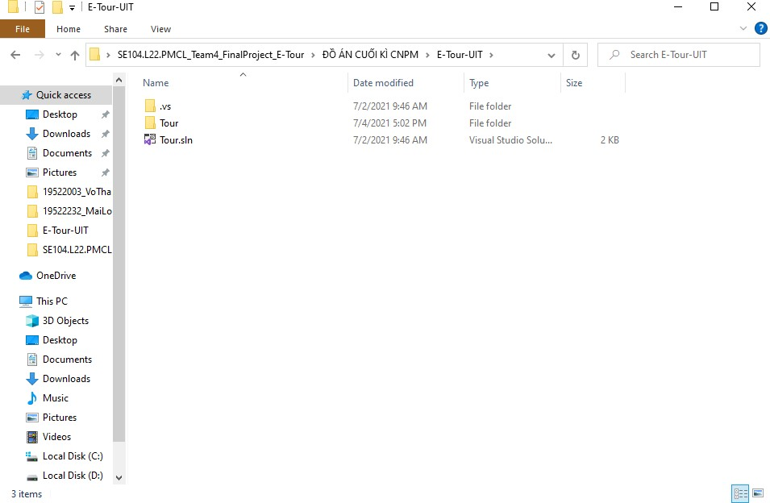

CLICK HERE TO OPEN

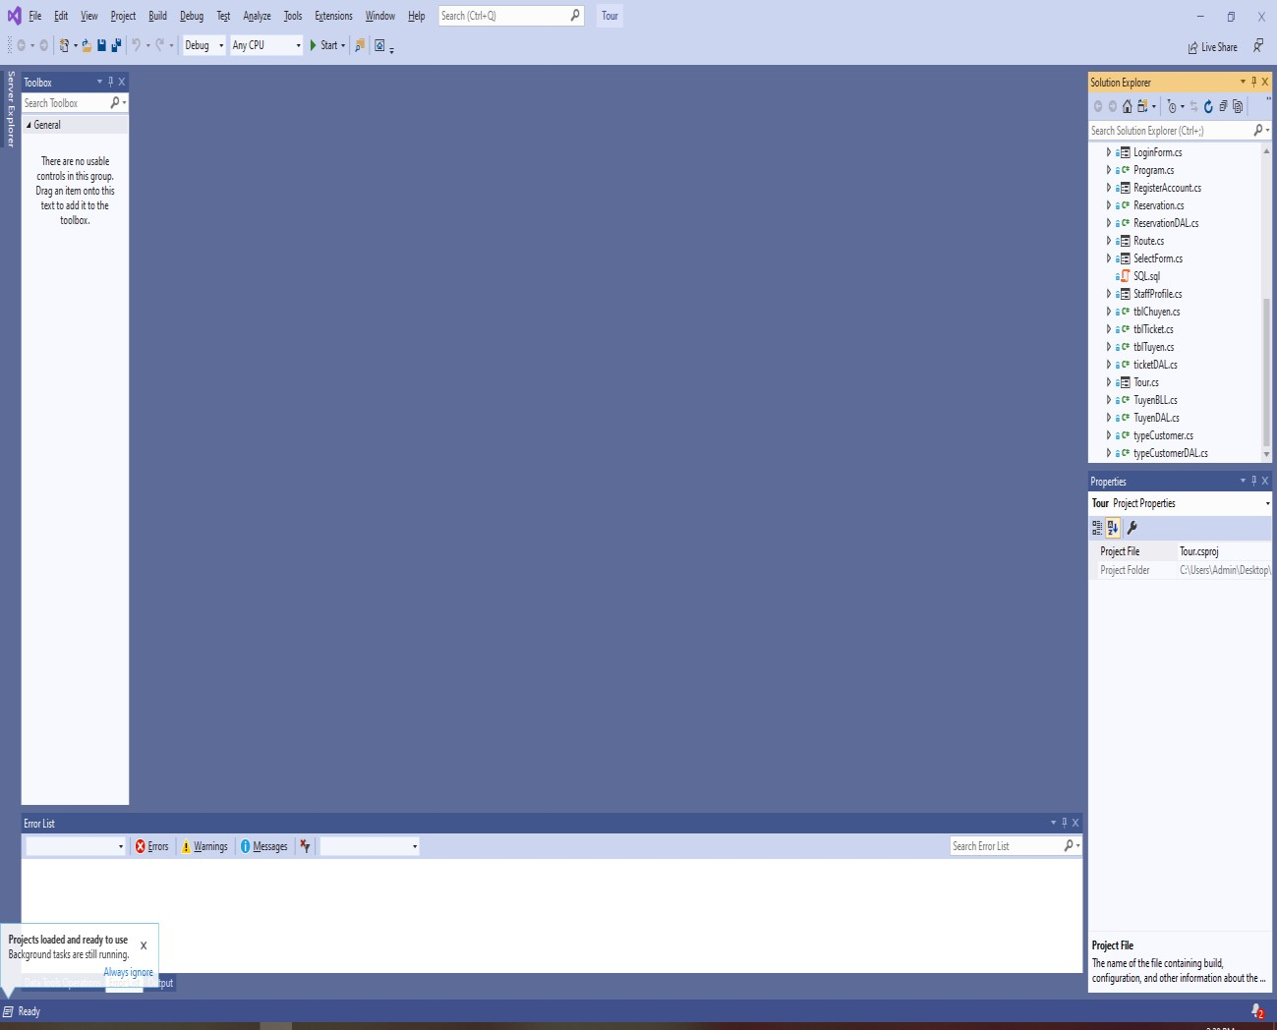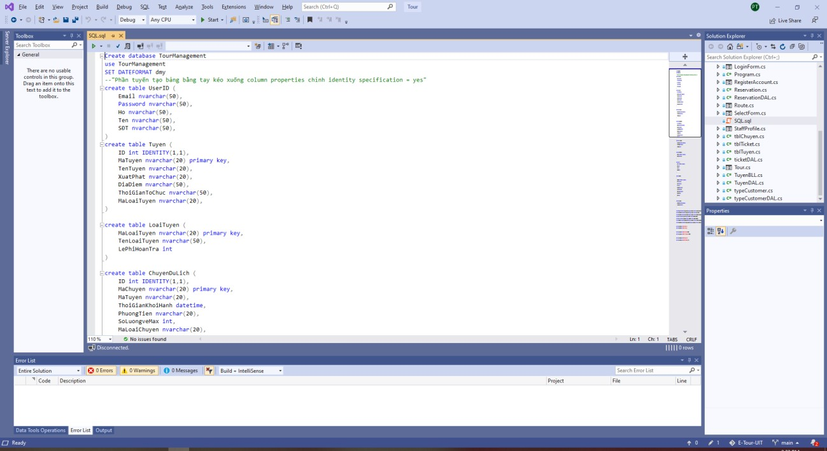

AFTER THAT, YOU COPY ALL THE TEXT IN THIS FILE AND GO TO SQL SERVER MANAGEMENT STUDIO

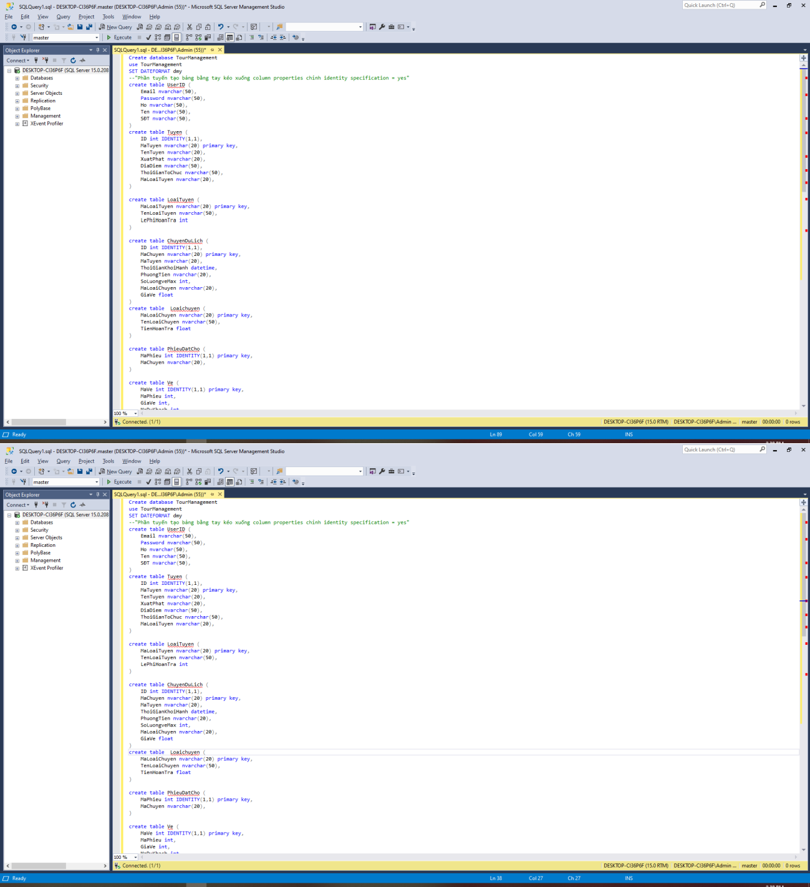

Click New Query

And paste all the text you have copied

before

Highlight all and click

button Execute

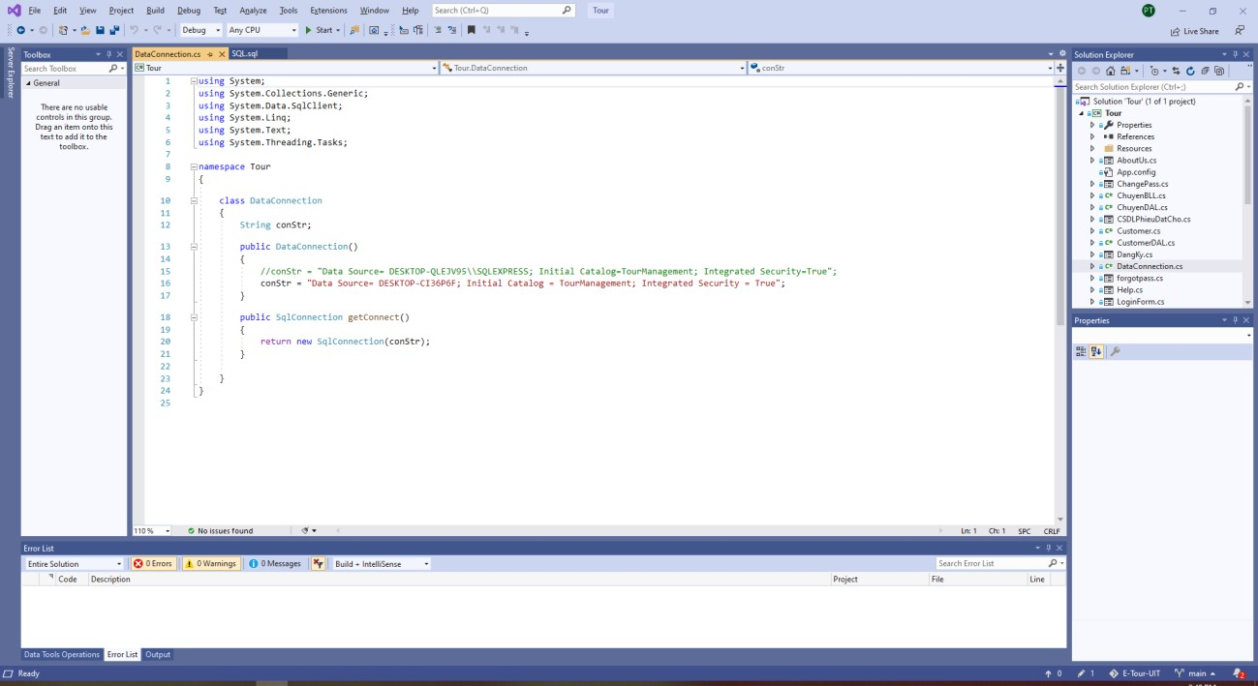

Get the connection

string from your SQL and Paste here.

AFTER THAT, YOU

COMEBACK TO VISUAL STUDIO CLICK FILE

Dataconnection.cs

Click View→ Server Explorer→Choose DataConnection(If you don’t have just Add it)

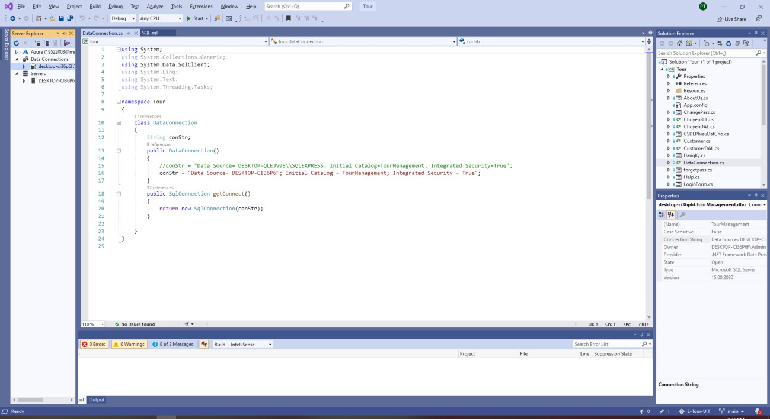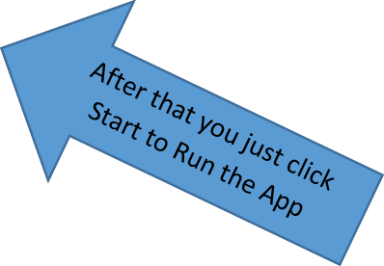

# Guide UI:

## This is Login Interface:

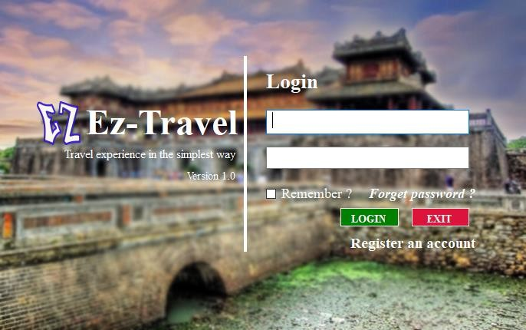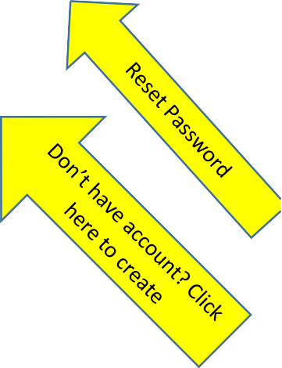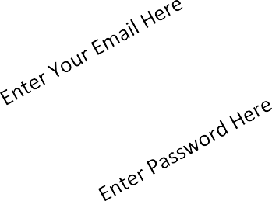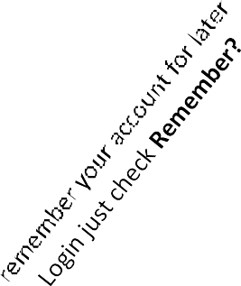

**Menu Interface:**

Manage:

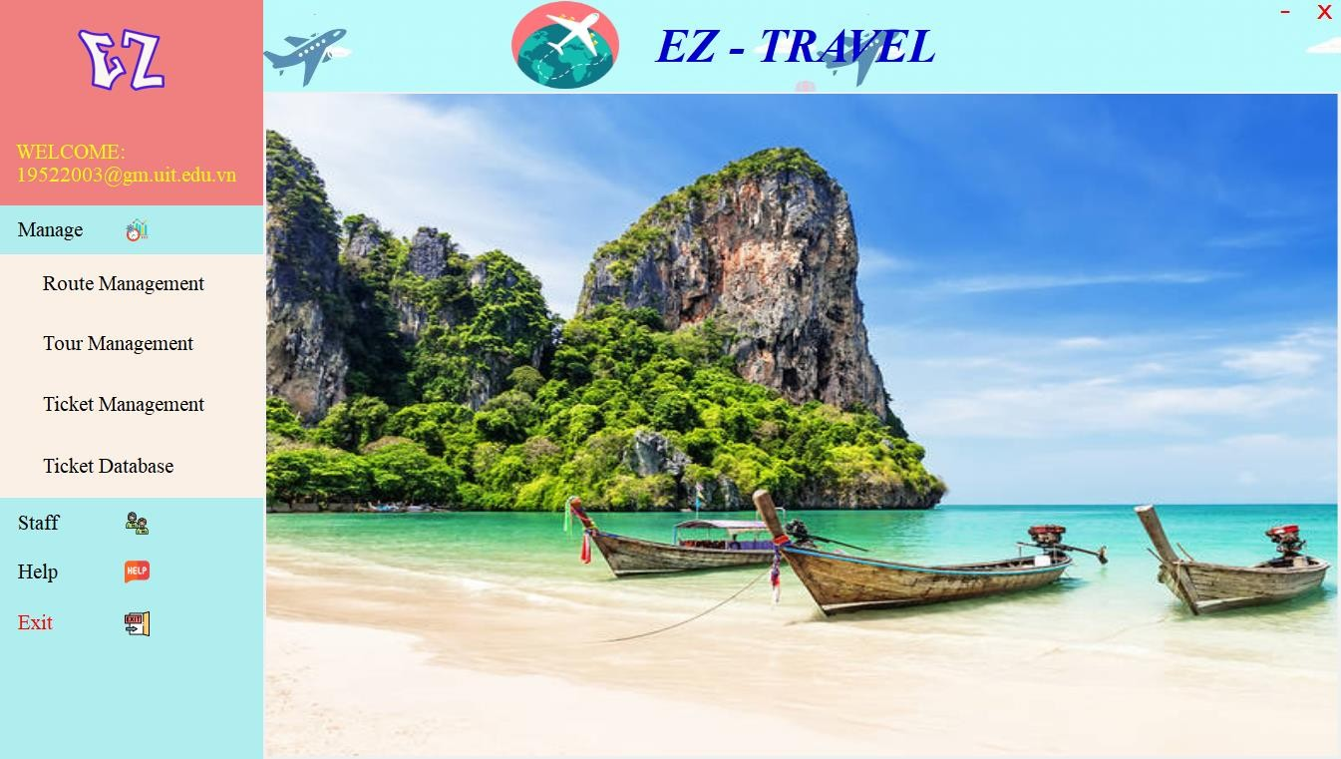

Click Here to Manage Route Click Here to Manage Tour Click Here to Manage Route Click Here to go to Ticket

Staff:



Click Here to go to your Profile

Click Here to Change Password

Your Profile:

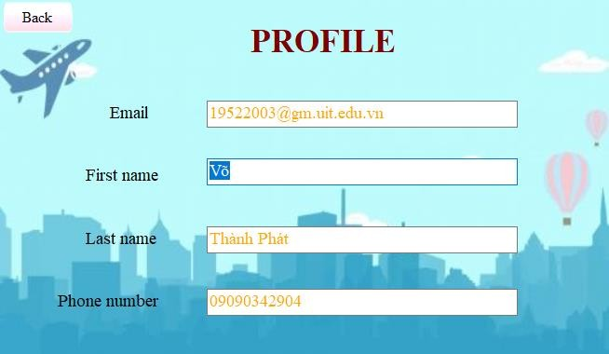

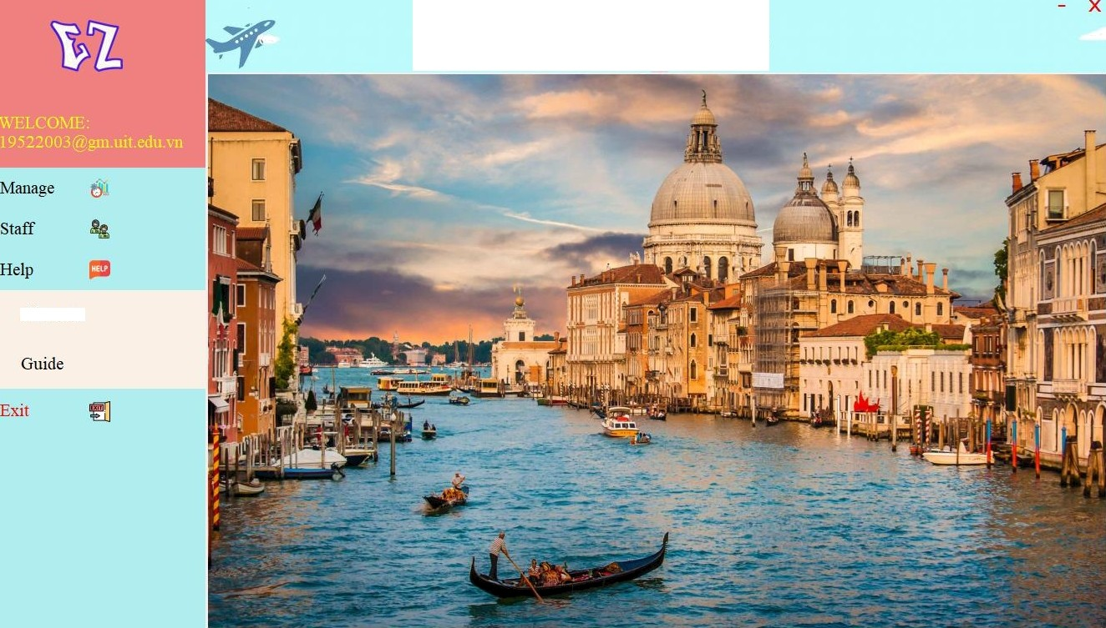

*EZ - TEL*

About us

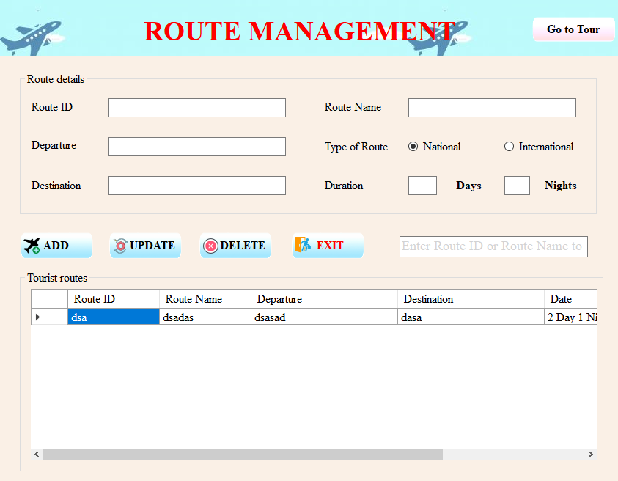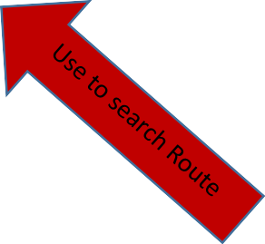

After enter all the Route

information You can click 4 buttons with their function

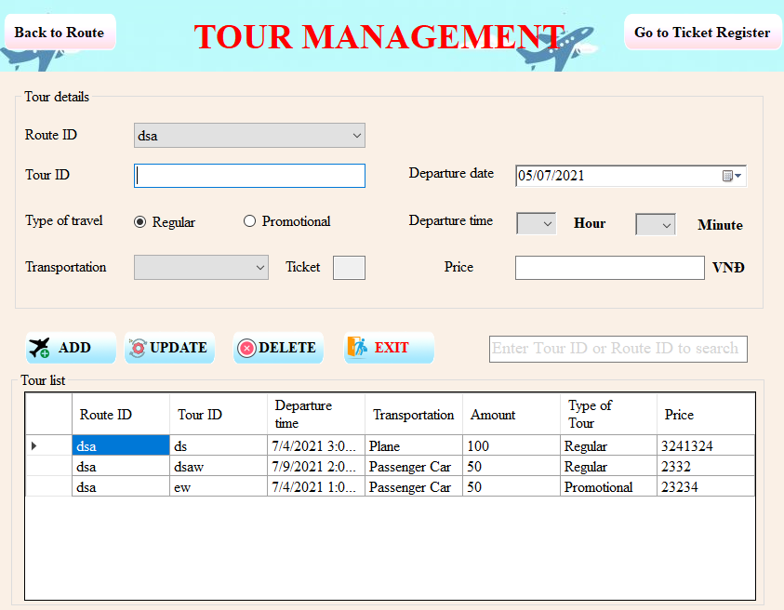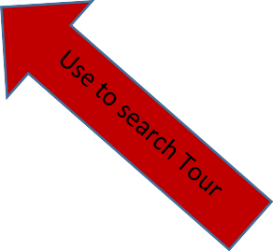

After enter all the Tour

information You can click 4 buttons with their function

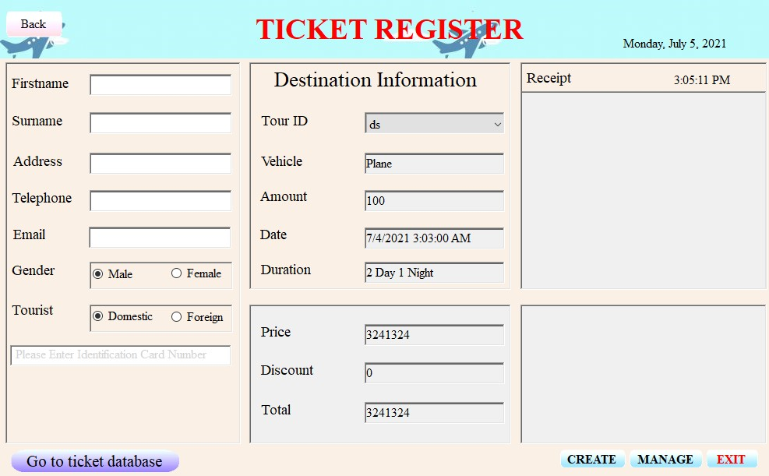

Enter all information and

click Create. The ticket will release

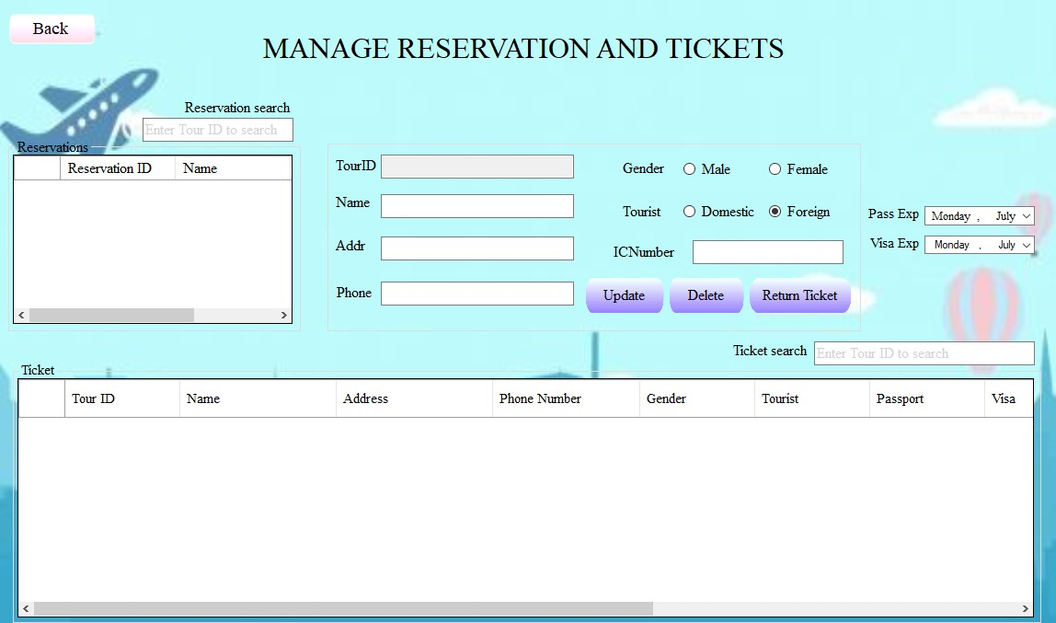

At here we have 2 search textbox: 1 for search Tour ID, ticket, customer Information. And 1 for searh Reservation ID and Customer Name.

You can click button Refund to show the money the customer have to pay back if they want to refund the ticket.

The Update and Delete are the same with the button in Tour, Route. After you Refund the ticket for customer. You should Delete that ticket out of System.